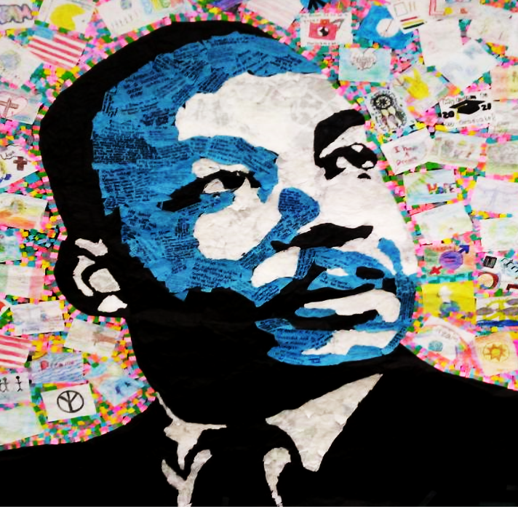
Applications and Guidelines

INDEX

- Competition Application………………………………………………. Pg. 2

- Art Competition Guidelines…….………………………………. ……. Pg. 3

- Essay Competition Guidelines……….………………………………...Pg. 4

- Oratory Competition Guidelines……….……………............................ Pg. 5

- Oratory Judging Criteria………………………......................................Pg. 6

- Performing Arts Competition Guidelines………………………. …….. Pg. 7

- Photography Competition Guidelines……….….………………………Pg. 8

- Poetry Contest Guidelines…………..……...….......................................Pg. 9

- MLKCC Achiever Scholarship Guidelines……………………………. Pg. 10

- MLKCC Achiever Scholarship Application…………………………...Pg. 11

MARTIN LUTHER KING JR COORDINATING COMMITTEE

2022 Annual Competition Application

This application MUST be filled out completely for each entry by an applicant. Incomplete applications will not be accepted. Competition Category: (Please check which category)

□ Art □ Essay □ Oratorical □ Performing Arts □ Photography □ Poetry

Section A:
First Name Last Name ______
Mailing Address ______
City ___State Zip Code________________
Grade Age Email Address ______
Name of School/Teacher (Please indicate if home-schooled) __________________________________
Parent/Guardian Name: Phone #______________________________
Section B:
This section is for Performing Arts Contestants only. (If you are not a Performing Arts Contestant, please proceed to section C.)
Performance Division: Vocal Monologue Instrumental
Dance Rap Theater

Competition Division : Solo Duo/Trio Group (4-8) Line (9-15)

Note: Group competitors must complete individual application forms.
Equipment Request: MLKCC-WPB will provide onsite microphones, music stand, a piano, and a CD player. All other equipment must be provided by contestants.

Section C:

Disclosures/Liability: Images of entries may be reproduced for marketing and publicity purposes. Students and the public may photograph artwork. Utmost care will be given to all entries. However, MLKCC-WPB cannot assume any responsibility for the damage or loss of entries in transit. It is the responsibility of entrants in the photography competition to secure the necessary releases from identifiable persons shown in all images. I/We understand the information printed above and agree to comply with MLKCC-WPB rules and regulations regarding the 2022 competition.

2022 Fine Art Competition ___________________Guidelines

THE ART COMPETITION IS THEME RELATED

Deadline: Saturday, January 1, 2022

Qualifying: Levels: □ Level 1 (k-3) - □ Level 2 (4-5) - □ Level 3 (6-8) - □ Level 4 (9-12)

Guidelines: Art must be submitted with a completed application form. Entries submitted without an application will be rejected. Applications should be typed or printed and attached to the back of the entry. Read and reread the theme, rules and consideration thoroughly.
Entries must be original artwork, digitized manipulated art is not accepted.
All entries must be mounted on tag or poster board. Minimum size 8 ½ x 11.

Media: Tag, Poster board, Pen, Pencil, Markers, Crayon, Collage materials, Tempera, Watercolor, Charcoal, Clothe etc.

Considerations:
- Teachers, students should consider subject matter in relation to the theme, creativity, and originality in making selections for entries.
- Entry should have Theme included on the entry.
Application: Copy or download as needed from website: www.mlkccpbc.org
Teachers name and school must be included on application

Judging: The art will be judged by an impartial panel of judges. Presentation of winning entries will be made on Thursday, January 13, 2022 at the Classroom Teachers Association Building, 715 Spencer Drive, West Palm Beach at 5:00 pm.

Display: After the MLK Celebration, student artwork will be displayed at selected City/County Libraries during the month of February.

Awards: 1st, 2nd, and 3rd place award will be given at each level, Certificates will be given to all entrants, regardless of their placement.

Returns: Art entries will be returned upon request after the end of February.

Resume: The artist’s resume and photo should be available upon request.

Mail Entries to: Attn: Edith C. Bush - 1444 8th Street -West Palm Beach, FL 33401

2022 Essay Competition ____________Guidelines

THE ESSAY COMPETITION IS THEME RELATED

Deadline: Saturday, January 1, 2022

Qualifying levels: □ Level 1 (k-3)100 min-250 words max □ Level 2 (4-5)200 min-400 words max □ Level 3 (6-8) 300 min-500 words max □ Level 4 (9-12) 400 min-800 words max
Guidelines: a. Essays must be submitted with a completed application form. Entries
submitted without an application will be rejected. Applications should be typed or printed and attached to the essay.
b. Essays must be original and not previously published. Essays may not be used to participate in the oratorical competition.
c. Essays should be well organized, should state the theme, use literary
techniques, provide supported facts for arguments, be creative adhere to word count and draw a conclusion.
d. Essays should use descriptive language, interesting ideas, good grammar and spelling.
e. Essays should be typed or neatly printed; name/grade/school should appear on all pages of the essay. Illegible entries will not be judged.

Considerations: Teachers should consider a guide to writing a Basic Essay as a useful model Students.

Application : Copy or download as needed from website: www.mlkccpbc.org

Judging: The essays will be judged by an impartial panel of judges. Winning entrants will be notified upon completion of the judging. Awards will be presented at the Annual MLKCC-WPB, Breakfast, Monday, January 17, 2022.
Awards: 1st, 2nd, and 3rd place awards will be given at each level. Certificates will be given to all entrants, regardless of their placement.

Return of Essays: Entrants should make a copy of their essay before submitting it for judging. All essays become the property of MLKCC-WPB and may be returned upon request.

Resume: The entrant’s resume and photo should be available upon request.

Mail to: MLKCC-WPB - Attn: Edith C. Bush – 1444 8th Street – West Palm Beach, FL 33401
2022 Oratory Competition __________Guidelines

THE ORATORY COMPETITION IS THEME RELATED

Deadline: Friday, January 7, 2022
Qualifying levels: □ Level 1 (k-1) - □ Level 2 (2-3) - □ Level 3 (4-5) - □ Level 4 (6-7)
Time Restrictions : 1-2 minutes 2-3 minutes 3-5 minutes 3-6 minutes
□ Level 5 (8-9 - □ Level 6 (10-12)
6-7 minutes 7-9 minutes
Guidelines: Entrant must submit four (4) copies of oratory speech with a completed application form. Entries submitted without applications will be rejected. Applications should be typed or printed and attached to the speech. Entrant not in compliance with the time restrictions will be penalized. All speeches must be memorized, positive in nature, and theme related. Any help from judges will result in a reduction of the points. No props may be utilized during the presentation of the speech. The criteria for scoring can be found on pg.5.
Entrants must be onsite no later than 8:30 am.
Considerations: Teachers should consider subject matter in relation to the theme, creativity, and originality in making selections for entries.

Application: Copy or download as needed from website: www.mlkccpbc.org

Competition Date/Location:
The Oratory Competition will take place on Saturday, January 8, 2022 at:
West Palm Beach, FL

Opening Ceremony - 9 :00 a.m. - Competition Begins - 9 :15 a.m.

Judging: The speeches will be judged by an impartial panel of judges. Winning entrants will be notified upon completion of the judging.
Awards: 1st, 2nd, and 3rd place award will be given at each level. Certificates will be given to all entrants, regardless of their placement.

Return of Speeches: Entrants should make a copy of their oratory before submitting it for judging. All speeches become the property of MLKCC-WPB.
Resume: The entrant’s resume and photo should be available upon request.

Mail to: MLKCC-WPB - Attn: Bettye Dawson or Patricia Johnson - 1444 8th Street - West Palm Beach, FL 33401

2022 Oratory Judging Criteria _______Guidelines

Judging Criteria for the Oratorical Competition

- Visual Delivery
Eye contact through eye sweep and expression

- Formal posture
Effective stance, showing no nervous mannerisms, swaying, shifting

- Movement
Effective use of body movement to show visual breaks, reinforce message

- Gesture
Effective appeal of hand motions to create a visual impact

- Introduction
Effective attention Getter to gain interest and establish topic

- Theme
Creative development of the chosen theme reflecting careful analysis of subject

- Motivational Appeal
Ability of the speaker to “Reach out” Thereby creating empathy

- Language
Creative phrasing showing effective vocabulary, transitions, and style

- Conclusion
Effective ending to summarize overall message and leave a memorable impact

- Technical Application
Speaker’s Effective rate, volume, and articulation

- Vocal Appeal
Speaker’s sincerity and generation of enthusiasm

- Overall Effectiveness

- Memorization

*All speeches must be memorized, positive in nature and reflect the theme of the current year. No props maybe utilized during the presentation of the speeches become the property of MLKCC-WPB.

2022 Performing Arts Competition ___Guidelines

THE PERFORMING ARTS COMPETITION IS THEME RELATED
Deadline: Saturday, January 1, 2022
Qualifying levels: □ Level 1 (k-3) - □ Level 2 (4-5) - □ Level 3 (6-8) - □ Level 4 (9-12)
Time Restrictions: 2 minutes max - 3 minutes max - 4 minutes max - 5 minutes max
Performance Division: Vocal - Rap - Monologues - Dance - Instrumental - Theatre

Guidelines: Students competing in the performing arts competition must submit a completed application form. Applications should be typed or printed. Entrants may only compete in one performance division and one act. Point deductions will occur for those not complying with the time restrictions. Vocalist/rappers are to perform with an instrumental track accompanist or a cappella. Singing with a recorded artist is prohibited. Teachers/parents of competing dancers will be given reserved seating. However, absolutely no visual coaching is allowed. Props may be used but must be supplied and removed by the entrants. Excessive scenery and special lighting may not be used.
Mandatory Audition:
A mandatory audition for all entrants will take place at 6pm on Wednesday, January 5, 2022 at:
West Palm Beach, FL 33407
Entrants must audition in-order to compete.

Considerations: Contestants will be evaluated on preparation, originality, stage presence, time limit, appropriateness of selection.
Judging:
The performances will be judged by an impartial panel of judges. The competition will take place on Saturday, January 8, 2022 – 7:00 p.m.

Awards: 1st, 2nd, and 3rd place award will be given at each level. Certificates will be given to all entrants, regardless of their placement.

Resume: The artist’s resume and photo should be available upon request.

Mail to: MLKCC-WPB - Attn: Elder Moses Porter - 1444 8th Street - West Palm Beach, FL 33401

2022 Creative Photography Competition _____Guidelines

The Photography Competition is category related. Entrants must choose from the following Categories:

Category: Equality Human Rights, Civil Rights, Activism, Culture & Heritage

Deadline: Saturday, January 1, 2022

Qualifying Levels: □ Level 2 (4-5 Grades) - □ Level 3 (6-8 Grades) - □ Level 4 (9-12 grades)
Guidelines
- Photographs must be submitted with a completed application form.
Entries submitted without an application will be rejected. Applications
should be typed or printed legible and attached on the back of the entry.
- A maximum of two photographs per entrant will be considered for judging.
- Photographs must be prints. Discs, slides and digitized manipulated photos will not be accepted.
- Black and white, color and sepia tone photographs are accepted.
- Entries must be the original work of the entrant and bonded to a mat board.
Photo Description: A title and brief description should accompany each photo, (maximum 300 words). This description should describe the setting, category chosen, and how the photo relates to the category chosen

Considerations: 1) Students should consider subject matter in relation to the theme,
creativity and originality in making selection for entries.
2) Entrants should be sensitive to the privacy of human subjects and may
need to obtain the permission of subject before photographing them.

Application: Copy or download as needed from website: www.mlkccpbc.org.

Judging: Photographs will be judged by an impartial panel of judges. Presentation of winning entries will be made on Thursday, January 13, 2022, at the
Classroom Teachers Association Building, 715 Spencer Drive, West Palm Beach Florida at 5:00 p.m.
Display: Student Photographs will be displayed at selected city/county libraries
during the month of February.

Entries: All entries become the property of MLKCC-WPB and may be returned upon
request.
Resume: Resume and photo should be available upon request.

Mail to: MLKCC-WPB - Attn. Edith Bush 1444 8th Street West Palm Beach, Florida 33401
2022 Poetry Contest _______________ Guidelines
April - National Poetry Month Celebration

THE POETRY COMPETITION IS THEME RELATED

Deadline: Saturday, January 1, 2022
Qualifying levels: □ Level 1 (k-3) - □ Level 2 (4-5) - □ Level 3 (6-8) - □ Level 4 (9-12)

Submission Criteria :
- All entries must be the original work of the student
- Poem must be no longer than 40 lines in length
- All entries must be reflective of the theme
- No entries will be accepted that contain profanity, language that is discriminatory (based on race, religion, creed, nationality, or gender)
- The students name should be placed on the application only and should not appear on any place on the poem itself
- All entries must be typed
- Plagiarism is considered fraud; any contestant found committing or submitting a poem they did not write themselves will be disqualified
- The judges may disqualify any entry at any time for failing to comply with contest rules

Awards: Will be awarded to the first, second and third place winners; all participants will receive a certificate of participation rights: All rights remain the soul property of the author/poet; however, the MLKCCC does reserve the right to publish the winning entries on its website, in its newsletter, other affiliated publications. Thursday, January 13, 2022
Judges: A panel of judges will review all entries - work will be judged based on creativity originality. Honorary Judge(s): In the event of a tie will broke the tie.

Resume: The Poets resume, and photo should be available upon request.

Application: Copy or download as needed from website: www.mlkccpbc.org

Mail to: MLKCC-WPB - Attn: Edith C. Bush or Rev. I. Renai Collins
1444 8th Street - West Palm Beach, FL 33401

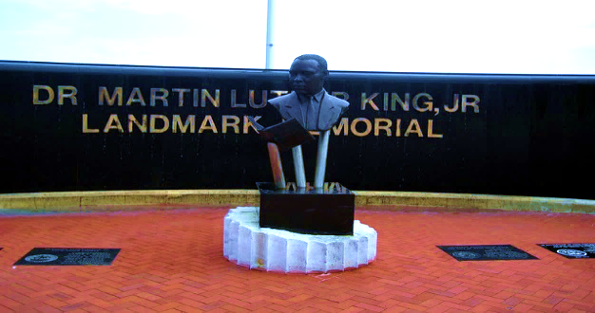

MARTIN LUTHER KING JR COORDINATING COMMITTEE-WPB

2022 Achiever Scholarship________________ Guidelines

ONLY COMPETITION PARTICIPANTS ARE ELIGIBLE

Qualifying Level: Grade 12
Guidelines: Students must complete and win 1st, 2nd, or 3rd place in at least one of the MLKCC-WPB events.
Student must complete a scholarship application before receiving their competition placement notification.
Criteria: Minimum 2.0 GPA
Deadline: Contact Edith C. Bush for details
Mail to: MLKCC Scholarship Attention: Edith C. Bush, Founder/Executive Director 1444 8th Street West Palm Beach, FL 33401
Questions: Questions regarding the application or scholarship guidelines should be emailed to edithcbush@gmail.com or call 561.832.4682
Application: Copy or download as needed from website: www.mlkccpbc.org
Announcement: All scholarship recipients will be notified via application contact information.

MARTIN LUTHER KING JR COORDINATING COMMITTEE-WPB 2022 Achiever Scholarship Application PLEASE PRINT INFORMATION IN BLACK OR BLUE INK

First Name___________________________Last Name________________________MI______
Mailing Address________________________________________________________________
City____________________________________State______________Zip Code ____________
Current High School/HomeSchool _________________________________________________
GPA____________Grauduation Date_______________________________________________
SS#__________________________________DOB____________________________________
PARENT/GUARDIAN INFORMATION

Mother’s Name___________________________ Father’s Name__________________________
Address_______________________________________________________________________
City____________________________________________State__________________________
Home Phone__________________________Cell Phone________________________________
Mother’s E-mail__________________________ Father’s E-mail_________________________
COLLEGE INFORMATION
Which College will you attend? ____________________________________________________
Number of College credits already earned? ___________________________________________
Major_______________________________ Minor_____________________________________
Additional Scholarship(s)/Grant(s): _________________________________________________
Confirmation of entries received will be sent, within one week of receipt, to the above email address. To ensure proper delivery, please add the MLKCC-WPB website - www.mlkccpbc.org to your domain safe website list.
Disclosures: I hereby certify that the information in this application is, to the best of my knowledge, true and correct. I have not knowingly withheld any facts that would jeopardize inclusion of this application.

Student Signature:___________________________________________________Date_______________
Parent/GuardianSignature:_____________________________________________Date______________

